Lesson 2.8 Heat transfer

Recommended teaching time for this lesson: 1 x 60 minute period

• 30 minutes of explicit teaching

• 30 minutes of suggested classroom activities

• 30 minutes homework

Getting started

Learning intentions & success criteria

|  |  |
| --- | --- |
| I will: | I can: |
| understand heat transfer. | * Define:   + thermal energy transfer. * describe:   + the process of conduction   + the process of convection   + the process of radiation. * identify:   + the type of heat transfer occurring in a given scenario. * explain:   + the heat transfer process involved in a given phenomenon. |
| understand the application of knowledge about heating processes to climate science. | * describe:   + an example of how an understanding of heating processes is used for understanding the effects of climate change. |

Key ideas

* Heat can be transferred by conduction, convection, and radiation.

Curriculum links

Science understanding

* Explain heat transfers in terms of conduction, convection and radiation.

Science as a human endeavour

* Explore the development of new technologies and understandings of heating processes as a means to predicting global temperatures and the effects of human-induced climate change.

Source: *Physics 2025 v1.1 General Senior Syllabus* © State of Queensland (QCAA) 2024

Advice for teaching this lesson

Things to know before you start teaching

Two activities have been written for you to choose between, as appropriate.

1. Observing heat transfers − videos: This version is a low-tech option involving videos that requires no preparation.
2. Observing heat transfers − classroom: This version will require you to collect some gear and talk with your lab technician before teaching the lesson.

Common misconceptions

* Students often believe that only one method of heat transfer is active at any one time.

Differentiation strategies

Physical demonstrations of conduction can be an appropriate teaching method. Have students line up across the room and then have one student at one end touch the shoulder of the student next to them, and then have that student tap the next and so on. You can vary this to demonstrate the different properties of conduction by playing with spacing, or even having a free electron run up the side of the line to show how a conductor works.

Other considerations

There are some opportunities for equations that are not within the syllabus document but could potentially make good student experiment topics for conduction. Convection has an equation but fluid dynamics makes for difficult experimental design in high school.

Starter activity: Touching temperature

Approximate time: 5 minutes

**Activity placement:** Place directly after Lesson overview

**Activity summary:** A touching activity that encourages students to consider that their senses can be misinterpreted.

Notes for the teacher

Potentially you could instruct students to do this before they enter the room to ensure that everything is as close to thermal equilibrium as possible.

Choose two to three different materials within the classroom. For example, the wood of a desk, the metal of the frame of a desk or a sink, and the plastic of a chair makes for excellent experiences.

Lead students through the questions after they have gathered their observations.

You could explain at the end or refer back to this once you teach about conduction and conductors.

Instructions for students

Step 1: When instructed to by your teacher, touch the different materials in the classroom.

* 1. Write down a relative temperature for each material (e.g. material A feels hotter than C, and C feels hotter than B).

Step 2: Consider the following questions.

* 1. What is the air temperature of the room?
  2. Are the objects you touched in thermal equilibrium with the room? Note: This is about reasoning from theory, not using your touching as evidence.
  3. What are the temperatures of the objects?
  4. How does this inference match with your observation?

Helpful hints

* No wrong answers, it’s just about feeling.

Answers

<Note to production: restart numbering below at ‘a.’>

* 1. Ideally students should find that plastic feels the warmest, then wood, then metal – but this is subjective.
  2. This depends on the air-conditioning settings.
  3. Yes, unless they touched plastic they have been sitting on, or wood they have been leaning on, the objects should be in thermal equilibrium with the air in the room.
  4. The objects should have the same temperature as the air.
  5. Observation/experience does not match the inference about the temperature.

Classroom activity: Observing heat transfers − videos

Approximate time: 15 minutes

**Activity placement:** Place directly above “How do convection, conduction and radiation work together?”

**Activity summary:** A set of video demonstrations of methods of heat transfer.

Notes for the teacher

If you choose to do the physical activities, these could be repeated for extra homework if desired.

If you plan on heat being a topic for the student experiment assessment mode, some of these videos can potentially make for good experiments to modify.

Instructions for students

Step 1: Watch the two videos below. For the different metals, record the time taken for each metal to melt the wax. For the candles on the metal bar, note the time taken to topple each candle.

Thermal conductivity of four different metals: <https://www.youtube.com/watch?v=akeb2d7hQ-A> (shows conduction in different metals)

Conduction of heat – observing heat conduction within a metal rod: <https://www.youtube.com/watch?v=LxJoLeeqk88> (shows conduction along length of metal)

<Note to production: restart numbering below at ‘a.’>

* 1. What can you state about the effect of different materials on the rate of conduction?
  2. Describe how heat moves through a conductor with reference to the length of the conductor.

Step 2: Watch the video below. Take note of the two stages used to demonstrate the convection current.

How heat convection of a gas works: <https://www.youtube.com/watch?v=VooYmwTLVgY> (shows convection in a cylinder)

<Note to production: restart numbering below at ‘c.’ **NOT** ‘a’.>

* 1. Draw the movement of the fluid in both stages of the experiment.

Step 3: Watch the video below. Take note of the temperatures at the start and end of the video.

<https://www.youtube.com/watch?v=AZWgDUy4dC4> – Radiation and different colours

<Note to production: restart numbering below at ‘d.’ **NOT** ‘a’.>

* 1. How does the colour of the flask affect the rate of radiation?

Helpful hints

* It doesn’t matter what side the hot air leaves during convection. Just pick one.

Answers

<Note to production: restart numbering below at ‘a’.>

* 1. Different materials melt faster. Highest rate of conduction is copper, then aluminium, brass, then iron.
  2. Heat moves from hot to cold, so the heat is conducted down the length of the metal melting the wax sequentially.

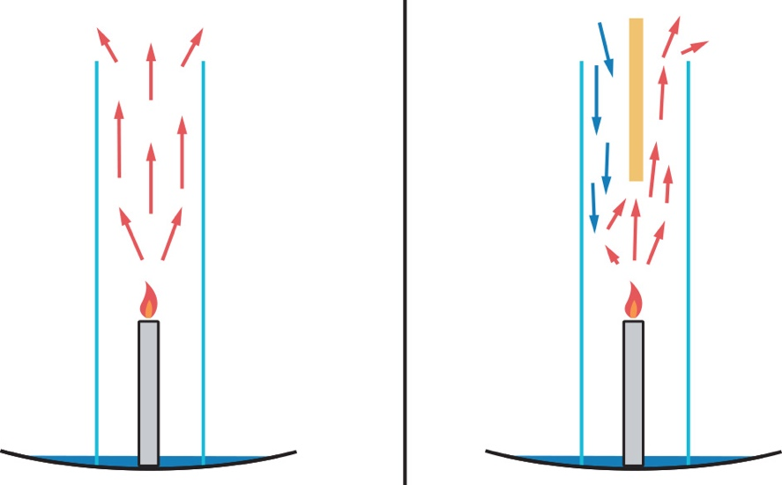

* 1. The silver flask absorbs less radiation than the black flask.

Classroom activity: Observing heat transfers − classroom

Approximate time: 15 minutes to conduct, 15 minutes to set up prior to demonstration

**Activity placement:** Place directly above “How do convection, conduction and radiation work together?”

**Activity summary:** A set of physical demonstrations of the properties of conduction.

Notes for the teacher

This version of the activity will require some setup. You can choose which demonstration for each method you would prefer to set up, but it will require preparation.

If you have the materials and your class size is large, you could set up stations and have students rotate.

Differentiation requirement: If you have students with forms of colour blindness, providing clear identification labels for the cellophane radiation activity is important for accessibility.

You may be able to ask your lab technician to set up these stations for you if you cannot prepare them before the lesson.

The student questions will work no matter which of these options you choose.

**Conduction**

Set up a 4-metal conductivity ring (search this term online if you need an image) with small amounts of wax in each divot. Use a Bunsen burner or directed heat source in the middle. Have students observe and participate in timing how long it takes the wax to melt. A video of Dr Walding demonstrating this is included in the other activity.

OR

Set up a metal bar held in a retort stand with one end over a Bunsen burner. Warn students not to touch this. Use an infrared (IR) thermometer to demonstrate to students that the end closest to the Bunsen is hotter than the distant end. A disassembled retort stand can make for an easy metal rod.

**Convection**

You will need a small conical flask and a larger beaker that the flask can fit inside.

Fill the conical flask up with hot water and add some food dye. The closer the water is to the brim of the flask the better.

Fill up the beaker with cold water. Chilled water will make for a better demonstration, but tap water is fine. Leave enough space at the top of the beaker so that the filled flask will not overflow the beaker.

Place the flask into the beaker. Students will observe the coloured water form a convection cycle.

OR

Create a candle carousel. A link for instructions is available at <https://www.science-sparks.com/create-a-candle-carousel/>.

**Radiation**

Place 30 mL of water into three 50 mL beakers. Wrap each beaker with a different colour of cellophane. Red, blue and green provide good distinction. Leave these next to an incandescent bulb lamp or out in the sun. Take measurements of the temperature after a period of 30 minutes. You may want to set this up at the start of the lesson so that they are heated for some time.

**DO NOT PUT THE THERMOMETER IN BEFORE YOU START**

Only use the thermometer at the end so that the thermometer is not exposed to the heat source as well.

OR

Leave a black piece of paper and white piece of paper out in the sun for 30 minutes. This is best set up at the start of the lesson. Make sure to anchor them down so they don’t fly away/flap about. Measure the temperature of each with an IR thermometer after 30 minutes when ready to examine.

Instructions for students

These steps may be performed out of order depending on the class size. Listen to your teacher’s instructions.

Step 1: At the conduction station, take observations about when things melt.

<Note to production: restart numbering below at ‘a’.>

* 1. What can you infer about conduction from this observation?

Step 2: At the convection station, take observations about how things move.

<Note to production: restart numbering below at ‘b.’ **NOT** ‘a’.>

* 1. What can you infer about the movement of heat in convection in this observation?
  2. What fluid is the heat moving through in this demonstration?

Step 3: At the radiation station take note of the temperature of the different items.

<Note to production: restart numbering below at ‘d.’ **NOT** ‘a’.>

* 1. What is the temperature for each colour?

Answers

<Note to production: restart numbering below at ‘a.’>

* 1. Bar on Bunsen: That conduction involves heat moving down the object, so the end near the heat source is hotter.  
     Wax on conductivity ring: That different materials will conduct heat at different rates.
  2. That heat moves from the source to rise up.
  3. Flask/Beaker Demo: Water  
     Candle Carousel: Air
  4. Answers will vary depending on the heat source.   
     Cellophane: Blue will be hottest, red coldest.  
     Paper: Black will be hotter than white.

Classroom activity: Graphic organiser summary

**Approximate time:** 10 minutes

**Activity placement:** Place directly above “Check your learning 2.8”

**Activity summary:** Using a circular graphic organiser to summarise key points of learning

Notes for the teacher

* Different levels of instruction will prompt students about more or less information.

Instructions for students

Access the graphic organiser template.

Circular graphic organiser

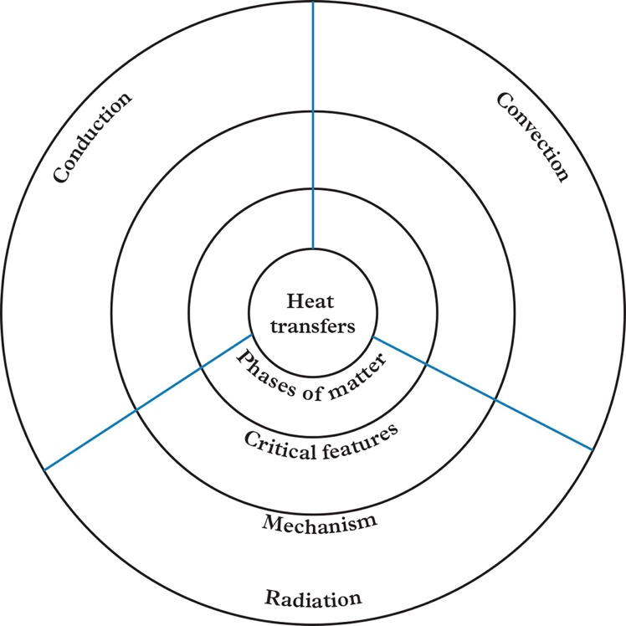

<Note to production: restart numbering below at ‘a.’>

* 1. Filling in the graphic organiser with information from Lesson 2.8. Table 1 can provide some helpful ideas for your summary.

Helpful hints

When looking for critical features, look through the text for bolded terms as this may be important.

Support activity

Notes for the teacher

The critical features have been provided for students.

Instructions for students

Access the graphic organiser template.

Circular graphic organiser

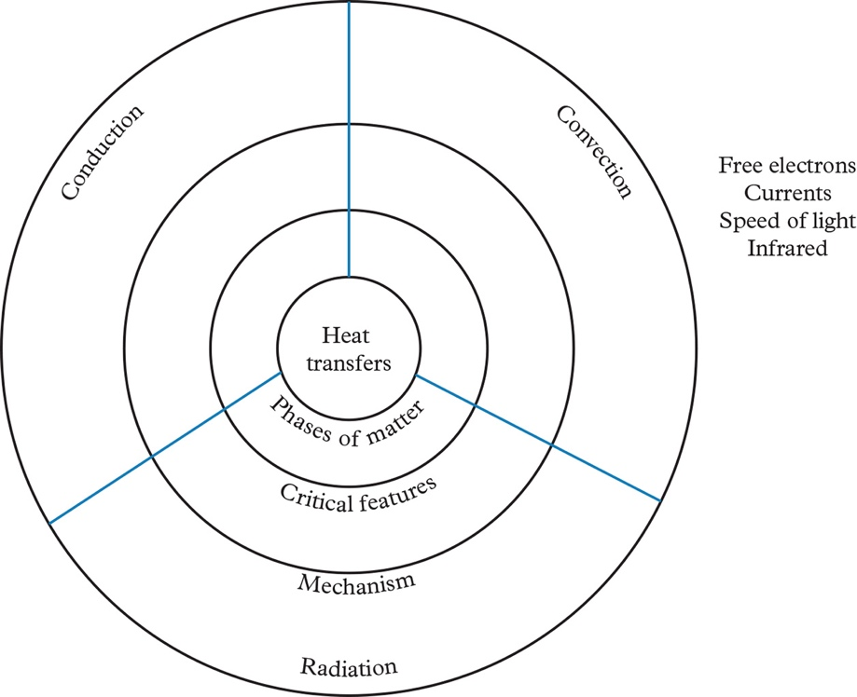

<Note to production: restart numbering below at ‘a.’>

* 1. Fill in the graphic organiser template using information from Lesson 2.8. Four critical features are on the organiser and should be placed in an appropriate place on your copy. Table 1 in Lesson 2.8 will provide some useful information for your organiser.

Challenge activity

Notes for the teacher

This template has less-structure to force the student to examine the notes and consider what would be the best way to structure their visual summary. You could potentially start off this activity with students to help them develop towards the core template, and then assign core/support as required.

Instructions for students

Access the graphic organiser template.

Circular graphic organiser

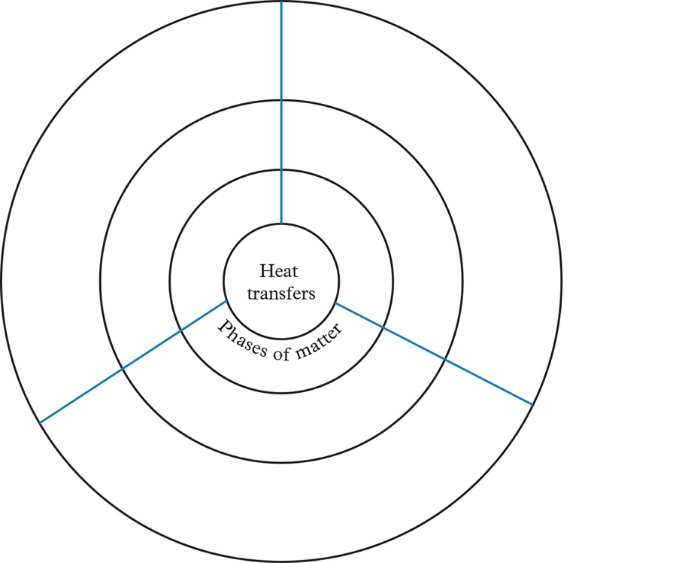

<Note to production: restart numbering below at ‘a.’>

* 1. Complete the graphic organiser template. The phases of matter should go into the inner-most ring of the template; however, the other two can be filled in with two sets of information that you feel is relevant. Table 1 in Lesson 2.8 can give you some suggestions, but there is more detail that is important in the rest of the text.

Answers

<Note to production: restart numbering below at ‘a.’>



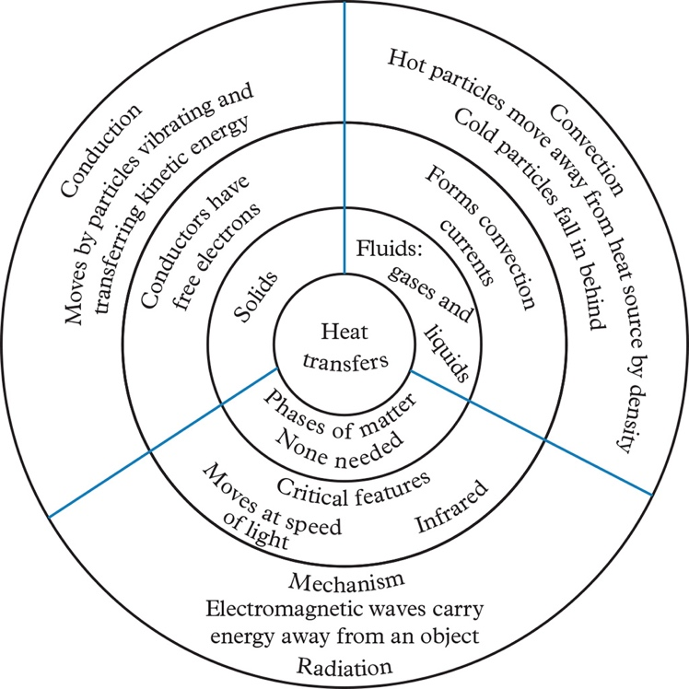

Support activity

<Note to production: restart numbering below at ‘a.’>





Challenge activity

<Note to production: restart numbering below at ‘a.’>

* 1. Student answers should vary. The following is a sample answer.

